## **1000 Norms Project**

- Blackpink

## 

## ***Project Background***

* **Project introduction**

1000 Norms project is aiming to create a free online portal to share the present health data with the healthcare community. The 1000 Norms Project Portal will be a central point of reference for physiotherapists, clinical researchers and other health professionals to access reference data, including details pertaining to reliability, validity and assessment protocols.

This project is processed by Jiayi Qin, Kaichun Zhang, Yuan Song, Jingyuan Wang, Lu Pan, Zhen Jia.

This project is managed by our client Dr.Marnee McKay.

* **Background of the organization and project**

Dr. Marnee McKay represents the Faculty of Health Sciences, Discipline of physiotherapy, University of Sydney. The Faculty of Health Sciences is known for world-leading health sciences education and research. They offer bold, innovative programs in six allied health professions at undergraduate and graduate entry level, as well as a general health sciences degree. The Faculty of Health Sciences ranked number two in the world of sports, physical therapy and rehabilitation (QS subject rankings 2018).

Faculty of Health Sciences was working on collecting the big data of human health information, preparing for ‘Big Idea’ project. Professor Maria Fiatarone, Michael Inskip and Dr Yorgi Mavros could be sitting on the next Big Idea to revolutionise healthcare. A finalist for the Big Ideas 2018 award for their product, HUMPHRE: The Holistic Unit for the Management of Personal Healthcare and Rehabilitation, the award recognises innovation in the development of a 'product' with the potential to revolutionise healthcare.

The Big Idea award ceremony will be hosted on Thursday, 21 June at Australian Technology Park, Eveleigh. All are welcome to come and support Michael Inskip and Dr Yorgi Mavros while they present their idea before the final judging. Interested faculty can see a program for the Big Idea Symposium (Thursday 21 June, Australian Technology Park, 3.30-5.30pm) and register to attend online.

* **Project problem**

To achieve the final goal of ‘Big Idea’ project, part of the project is to share the great range of health data with the public and attract more users, health workers to access to the data. One of the main problem is that the ‘Big Idea’ project need to be spread wildly via multiple mediums. Therefore this 1000 Norms Project is born working for this bigger plan, in order to create a free website portal sharing health data and also build reputation for the Faculty of Health Sciences. They need this website to be user-friendly and data accurately.

In order to guarantee the progress, we are making this project plan. Firstly we list the scope and project deliverables after the brief introduction. Then the schedule, including our roles and responsibilities, is made to ensure the project work is fairly distributed and can be done via each milestone.

***Project goals and objectives***

**Project Goals:**

In order to expand the institute's influence and attract more clients, the website created by 1000 Norms Project is open to the public and can be used free of charge. This website will provide a series of health assessments and provide users with appropriate health advice. Based on everyone's emphasis on health, this website will attract a large number of users. At the same time, the website has its own database and stores all user information, according to which the company can provide the corresponding services. And the design of the website includes tracking users, which can enhance the user's satisfaction with the company's services, it can solve the main problem met by the company effectively.

**Project Objectives:**

**Specific:**

* Users can get a health test result and advice after finishing a series of questions the website provided.

There are millions of real-world data should be analysed before design questions and results. The results should be reasonable according to the statistic analysis of data, which will use some mathematical method to deal with data to improve the accuracy of results.

* If it is not the first time for a user to use the website, there will be a test history record and all of personal information of the user.

This objective can be achieved using the database created to support login function, once the user already has an account, there will be a record in the database. The database can store personal information including name and password and testing history.

**Measure:**

* The database of the website should contain millions of user information.

Due to this website is used to the public, the database should be big enough to contain users’ information, at the same time, the speed and performance cannot be influenced by the large of data.

**Attainable:**

* The health assessments of the website will be created and analysed based on real-world dataset, which could improve the achievable of the project.

The organisation provides a dataset which contains 1000 data and each information includes age, gender, and other health measure results, these data can be treated as original dataset and any new input will be compared with the original dataset to get a reasonable health result.

**Relevant:**

* The website will record tracking of the users, which related to the company’s business objective and some corresponding services can be provided to users.

To achieve this objective, there should be some database structure design, which aims at recording the users testing history.

**Time-bound :**

* The 1000 Norm Project should be completed within ten weeks due to the update of the original dataset.

## ***Scope and Expectation***

1000 Norms Project will create a website which can be used by all users to measure their health situation, the website will be built based on an existed dataset which including a great number of personal health data. There will be a plenty of works to be done to achieve the goal.

Functional requirement:

1. The website must provide a survey which created by the dataset analysis for users to answer in measuring logic. (Customer requirement)
2. The website should provide the detailed explanation for each survey question to improve the result accuracy.
3. The website must display the mark results after users completing the test. The website should also analyze the mark and give appropriate health advice. (Customer requirement)
4. The website must have an interface which contains homepage, register page, testing and result analysis page and about us page. (Customer requirement)
5. The website must have a database to store millions of personal information. (Customer requirement)
6. The website should have a database to store users’ information and testing history results.
7. The website must connect the interface, the personal information database and users’ database by backend program.
8. The website should post videos to introduce the health measurement in the very middle of the main page.

Non-Functional requirement:

1. Security/Maintenance :

The website should be able to withstand over 100 usages.

(It is an evaluation criterion about whether the system is stable and strong enough.)

2. Availability :

The website server should be available for 24 hours/7 days.

(The user can use this application anytime and also increase the user satisfaction)

3. Performance:

The response time for the system should be less than 0.5 seconds.

(The website can provide fluency and more responsive user interaction, as well as further enhancing the user experience.)

Customer requirement:

(Some customer requirement are also functional requirement, we have said them in functional requirement)

1. The users must register and login before measuring health situation
2. The website should support third-party logins such as Facebook, Google and Twitter.

***Deliverables***

|  |  |  |  |  |
| --- | --- | --- | --- | --- |
| Deliverable name | Tasks | Description | Details | Responsible person |
| Data | Data Analysis | Analyse all examples in the dataset, group dataset. | Analyse each column and row of the dataset, remove bad samples.  Group data as different gender and age group. | Jiayi Qin |
| Data Calculation | Calculate user’s score correctly. | Calculate raw score, z-score and ped score according to user information. | Kaichun Zhang |
| Database | Database construction | Build a database to store users information. | Store user register information (email, password) and test marks for users to compare test results. | Yuan Song |
| Website | Website frontend design | Design the interface of our website. | Select colour, font size, icons and pictures.  Design web page structure and content.  Make prototype of main pages. | Jingyuan Wang |
| Website frontend build | Build the web pages as the design. | Build the web pages as the design. | Lu Pan |
| Backend Programming | Run the program to realize functions. | Do the programming to make sure all functions can run correctly. | Yuan Song |
| Connection of frontend and backend | Connect code of frontend and backend correctly. | Make sure there is no mistake and the programs can run well showing by the interface. | Zhen Jia |
| Final Website | A well-designed and executable website. | Make sure the website is well-designed and executable. | Jiayi Qin |

***Project schedule***

This is the detailed schedule of the whole project. This schedule contains WBS of the project and time, roles. A description also follows the detailed schedule.

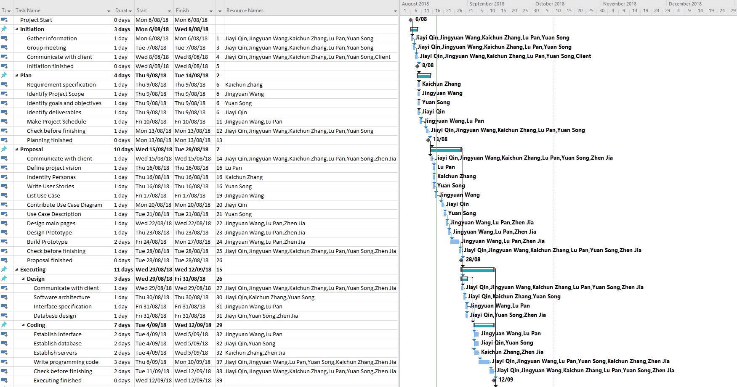

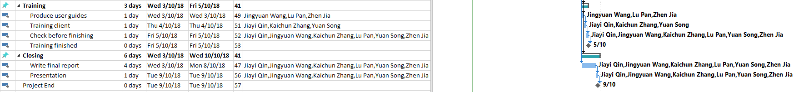

**Schedule description**

The project begins in the second week(6th August) of this semester and ends on week 11(10th October). The schedule is made based on waterfall methodology. There are 7 phases during this project.

The first phase is initiation continuing from 06/08/2018 to 08/08/2018. The project

group is responsible for gathering information, group meeting and communicating with client.

The next phase is project planning starting from 09/08/2018 and ending on 14/08/2018.

The project group is responsible for writing the plan report includes identifying scope, clarifying a series of requirements, making a schedule and identifying roles and responsibilities.

The third phase is making project proposal beginning on 15th August and ending on 28th August. After communicating with client, project group need to carry out a proposal which includes personas, user stories use case diagrams. A prototype will also be made during this period.

The project executing phase lies the 4th which is starting from 29/08/2018 and ending on 12/09/2018. There are 2 steps in this phase: design and coding. In the design step(29/08-31/08), after communicating with client, software architecture will be carried out, then interface and database will be designed. For the coding step(4/09-12/09), interface, database and the server will be established. Then program code will be written by our team.

Training is the 5th phase (03/10-05/10). User guides will be made and a face to face training will also be carried out.

Presenting phase will also start on 3rd October, which will last for 6 days ending on 9th October. Final report and presentation would be given during the period.

In order to ensure the project can be finished on time, we arrange some spare time before a phase is finished to prevent some accidents, such as client requirement changing, some task delaying and etc. These extra time is called “Checking before finishing”. It should be noticed that we will do some tasks parallel to save time. For example, training and closing phase are starting at the same time (when executing phase finishes), which means project team members will train client and write report simultaneously.